# BIGG BOSS VOTING ZONE

### A MINI PROJECT REPORT

#### Submitted by

#### Group/Team No: G20/T3

**Aaradhya Manak, 23100991754,**

**Aaron Vijay Singh, 23100991755,**

**Aastha Malik, 23100991756,**

#### in partial fulfillment for the award of the degree of

## BACHELEOR OF ENGINEERING

***in***

COMPUTER SCIENCE & ENGINEERING



**CHITKARA UNIVERSITY**

**CHANDIGARH-PATIALA NATIONAL HIGHWAY**

**RAJPURA (PATIALA) PUNJAB-140401 (INDIA)**

##### October2023

**Abstract:**

The html and CSS based project is a dynamic and visually captivating web application designed to facilitate the voting process for the renowned reality TV show, Bigg Boss. This project showcases an innovative and user-friendly interface, carefully constructed with Html for structuring content and CSS for creating an aesthetically pleasing design. The “Bigg Boss Voting Zone” project is a testament to the fusion of technology and entertainment , aiming to empower viewers by providing an accessible and engaging platform for voting, thereby increasing their participation in the show’s decision making process.

###### TABLE OF CONTENTS

|  |  |  |
| --- | --- | --- |
| Sr.no | Section | PageNo. |
| 1 | Introduction | 3 |
| 2 | Problem Statement | 3 |
| 3 | Technical Details | 3 |
| 4 | Key Features | 4 |
| 5 | Project Advantages | 4 |
| 6 | Results | 5 |
| 7 | Conclusion | 6 |
| 8 | Future Scope | 6 |
| 9 | References | 6 |

**Introduction**

**Project Title**: Bigg Boss Voting Zone

**Objectives:**

Our main goal for this project is­ to create a voting zone which looks dynamic, is user-friendly and interactive.

**Problem Statement**

A voting platform is to be designed to show the increase/decrease in the votes of particular contestant using html and CSS.

**Technical Details**

The technical details are as follows: -

1. Software Used: Notepad++
2. Basic html knowledge regarding interlinking , creating classes, use of div tags,etc.
3. Basic CSS knowledge regarding animations, padding, types of CSS, etc.

**Key Features**

1.Bigg Boss cover page and its ott logo to give a sense of security in minds of the users.

2.Navigation buttons given to navigate between different webpages through interlinking.

3.The User’s details page is assigned to collect the info of the users.

4.Animations are used on the Contestant page to make it look professional and skillfull.

5.Thanks page to assure the voters that their vote has been registered.

6.Result page to show the results using progress bars.

**Project Advantages**

* Interactive landing page to engage the audience.
* Animations are added to make the pages look skilfull and professional.

**Results**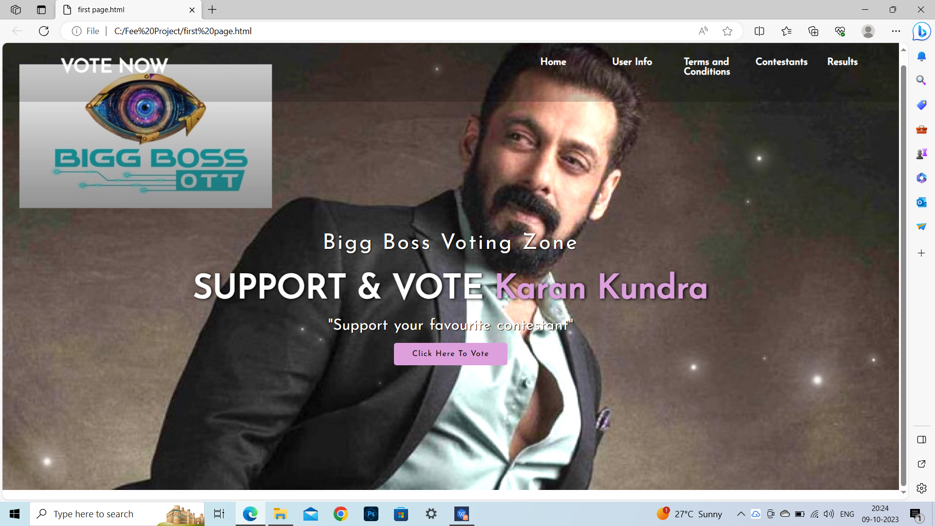

Fig 1. First Page

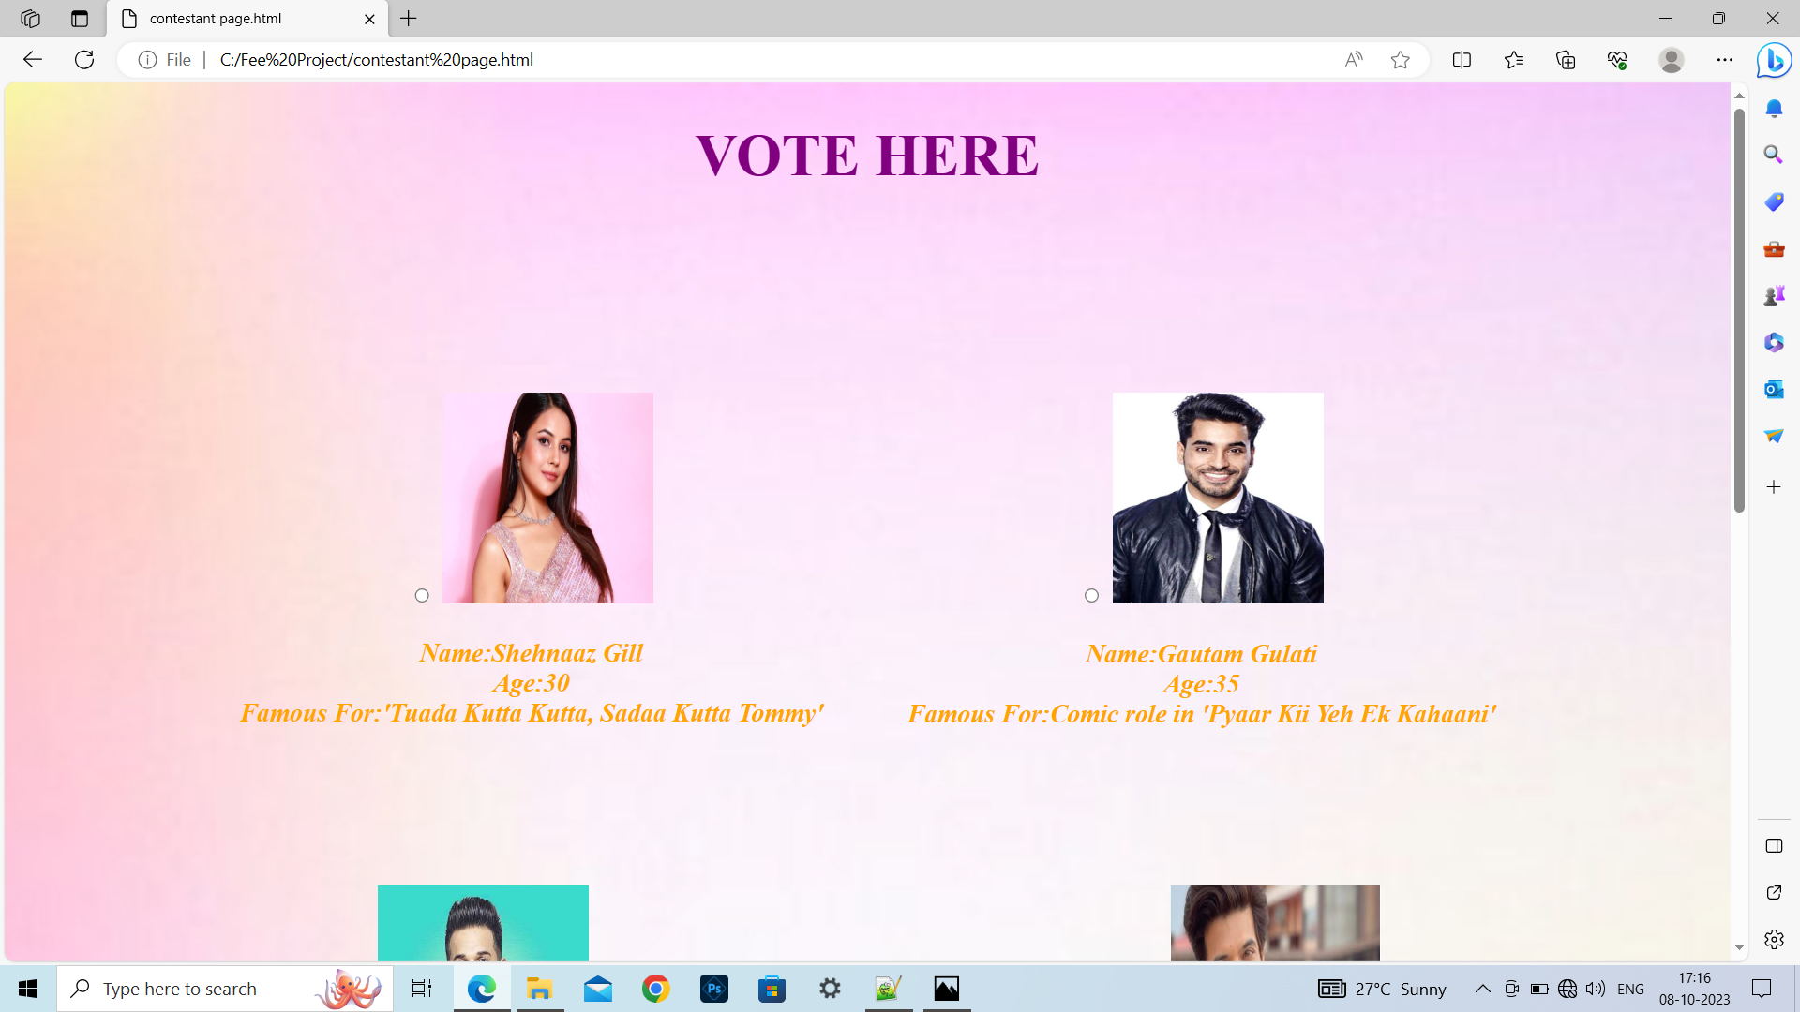

Fig 2. Contestant Page

**Conclusion**

* The project is made using different tags of html, different styles of CSS, their co-relation with each other, so our major takeaways are the use of these tags and properties and become familiar and comfortable with them.

**Future Scope**

* Enhanced result generating through JavaScript.
* Better co-relation of features in the webpages.

**References**

* <https://fonts.googleapis.com/css2?family=Josefin+Sans&display=swap>
* https://cdnjs.cloudflare.com/ajax/libs/animate.css/3.7.2/animate.min.css
* W3schools.com
* Youtube.com